Adi Keinan-Schoonbaert and Gethin Rees (2020), 'A Season of Place: Teaching Digital Mapping at the British Library', Journal of Map & Geography Libraries https://doi.org/10.1080/15420353.2020.1719267
Abstract
One of the British Library Digital Scholarship team’s core purposes is to deliver training to Library staff. Running since 2012, the main aim of the Digital Scholarship Training Program (DSTP) is to create opportunities for staff to develop the necessary skills and knowledge to support emerging areas of scholar-ship. Recently, the Library has been experimenting with a new format to deliver its training that would allow flexibility and adaptability through modularity: a “season”.The Digital Scholarship team organized a series of training events billed as a “Season of Place”, which aimed to expose Library staff to the latest digital mapping concepts, methods and technologies, and provide them with the skills to apply cutting-edge research to their collection areas. The authors designed, coordinated and delivered this training season to fulfill broader Library objectives, choosing to mix and match the types of events and methods of delivery to fit the broad range of technologies that constitute digital mapping today. The paper also discusses the impact that these choices of methods and content has had on digital literacy and the uptake of digital mapping by presenting results of an initial evaluation obtained through observation and evaluation surveys.

Introduction
The British Library is the national library of the United Kingdom, and is home to over 170 million items from all over the world. These include items in both physical and digital format, such as books, manuscripts, journals, newspapers, magazines, sound and music recordings, videos, play-scripts, patents, databases, maps, stamps, prints and drawings, and more. Since the 1990s the Library has been engaged with digitization projects alongside acquiring and archiving increasing volumes of born-digital content, initiatives that have presented a wealth of new access opportunities. The British Library is also a major research library and aims to support and stimulate research of all kinds. We aim to inspire both those who physically visit our sites as readers and those across the country and the world who consult our resources online and engage in myriad other ways. Digital mapping can help the British Library to fulfill many of these core aims. Geographical concepts like place help audiences who are unfamiliar with a collection to engage and understand its scope. Web maps aid access whether through driving users to content in which users are already interested, or by inspiring serendipitous discovery. Those same web maps and other geospatial tools can stimulate innovative research by presenting geographical patterns. These applications rest on the creation of geospatial data from the Library’s content or metadata. Exploiting this potential requires training, and this paper outlines how we organized, structured and delivered a “season” of events that aimed to empower staff to use digital mapping.
Digital Scholarship
The Digital Scholarship department was created in 2010 to enable the use of the British Library’s digital collections for research, inspiration, creativity, and enjoyment. The department aims to meet the needs of a fast-changing research landscape and to support scholars who wish to deeply integrate digital content, data, and methods into their work. As such, it works closely to understand their needs, enable access to digital collections, and provide guidance and technical assistance so that the Library can support areas of modern scholarship such as the Digital Humanities. A key function of the department is investment in the development of staff skills and core competencies through its Digital Curator team, as Library staff are increasingly keen to analyze, visualize, and enhance the digital collections in their custodianship.
In 2012, the Digital Curator team embarked on a plan to design and deliver a bespoke training program for staff, the Digital Scholarship Training Program (DSTP; McGregor and Farquhar 2013; McGregor et al 2016). The team set four objectives to guide and measure the success of the program:
- Staff across all collection areas are familiar and conversant with the foundational concepts, methods and tools of digital scholarship
- Staff are empowered to innovate
- The team’s internal capacity for training and skill-sharing in digital scholarship are a shared responsibility across the Library
- Collaborative digital initiatives flourish internally and externally, with staff being equal partners and even leading on digital scholarship research
The Digital Curator team devises and delivers in-house a series of one-day, hands-on courses suited to building the digital skills of information professionals in the research library and cultural heritage sector. Complementing these training days, the team has developed a bespoke pro-gram of hands-on workshops, lectures and reading groups, through which it raises awareness of the opportunities new digital methods bring to the Library’s users.
The Season of Place
In autumn 2018 the Digital Curator team has established a new experimental format for delivering training around specific themes, which is referred to as “seasons” or “strands” (M. Ridge, “Introducing an experimental format for learning about content mining for digital scholarship,” December 7, 2018, https://blogs.bl.uk/digital-scholarship/2018/12/introducing-an-experimental-format-for-learning-about-content-mining-for-digital-scholarship.html).
Taking into account colleagues’ workload and different working patterns, our aim was to ensure that there are sufficient opportunities for staff in a variety of roles at the Library to engage with digital research. Providing a more diverse and flexible training offering, with training delivered through modules of different lengths and methods, was regarded as an effective way of building staff knowledge and skills in a particular area over a period of several months. Staff members are then free to choose between different training modules according to their previous knowledge and expertise, their interests, and their preferred modes of learning. This paper will discuss the Season of Place—a series of talks, hands-on workshops and training days formulated around the topic of digital mapping (A. Keinan-Schoonbaert, “The ‘Season of Place’—learning about all things digital mapping,” April 24, 2019, https://blogs.bl.uk/digital-scholarship/2019/04/the-season-of-place-learning-about-all-things-digital-mapping.html).
The paper will look into concepts, methods and technologies we covered, the types of events and methods of delivery chosen and the impact that these choices had, the latter through presenting the results of evaluation surveys of two training courses delivered as part of the season.
Digital mapping has been a popular topic amongst British Library staff as our collections are rife with interesting geographical information from place of publication to place names mentioned in text. The Season of Place therefore aimed to help staff:
- Understand the geographical information embedded within collections and its relationship to geospatial tools and technologies
- Develop skills in geospatial research methods to foster research on the Library’s collections
- Use digital mapping to diversify methods of accessing collections
- Spark inspiration through case studies and examples of cutting-edge visualizations using digital maps
Planning and designing training to achieve these aims presented us with several challenges. To start with, we had to cover the large and complex topic of digital mapping in a short period of time. Secondly, the season was aimed at a varied audience, working in a variety of roles and collection areas but also with widely differing levels of technical ability and experience. Third, participants would not attend all modules within the season. Fourth, we had to work within the technical, physical and financial resources and constraints of the Library, including available software, teaching spaces and limited funds for additional personnel or resources. Finally, although we identified three general areas for applied learning—research, access and inspiration—it is not always easy to predict applications of digital mapping across a large institution like the British Library. Therefore, by increasing literacy in key areas and exposing participants to a range of relevant tools, we aimed to inspire participants to seek out innovative applications. With these aims and challenges in mind, we have designed, coordinated and delivered a series of events on digital mapping running from December 2018 until the end of March 2019.
Training Design and Methods of Delivery
A season of events offers the diversity in approach and flexibility of deliv-ery to provide an excellent method of meeting the aforementioned aims and challenges. Staff would be exposed to everything from high level con-cepts in presentations delivered by external academics to practical tuition in tools that are directly related to the Library’s collections and participants’ roles. We will now examine the modular approach and how we planned and delivered the Season of Place.
DSTP Courses
At their inception, the Digital Scholarship Training Program’s (DSTP) full-day courses were planned and designed in consultation with internal and external experts working in leading institutions promoting digital scholarship. The Digital Curator team has been teaching a wide variety of topics, including but not limited to Digitization at the British Library, Crowdsourcing in Libraries, Museums and Cultural Heritage Institutions, Geo-referencing and Digital Mapping, Information Integration: Mash-ups, APIs and Linked Data, Information Visualization (including simple mapping exercises), Metadata for Electronic Resources, and Cleaning up Data (OpenRefine). Courses are delivered by a mix of internal and external trainers. Each training day, lasting between five and six hours, follows a broadly similar format consisting of a mixture of talks and hands-on tutorials with digital tools. Course materials including slides and exercises are made available to Library staff through an internal wiki.
In planning the season’s training days, we chose to spend the lion’s share of our training time teaching tools that provide participants with concrete skills that they could go on and apply in their roles. This emphasis on practical training conforms to the physical setup of the classroom. DSTP courses are usually delivered in a room specifically designed for training. The room’s arrangement is L-shaped with additional desks in the center, setting up participant expectations for a workshop-oriented and collaborative mindset, rather than frontal, non-participatory presentations. The room allows for 15 participants, each provided with a desktop PC or a laptop. We divided our training into two days, one month apart, to allow a sufficient number of topics and tools to be covered, as well as offering choice for participants according to their interests and needs. The first training day was geared toward creating and visualizing geospatial data, and the second was focused on how to use visualizations and conduct analysis within digital research. The training therefore encompassed the three core components of Geographical Information Systems: data, visualization, and analysis (Huisman and de By 2009, 32). These categories offer a useful heuristic for examining mapping in the 21st century as a whole beyond GIS.

Introductory Talks
Despite a strong focus on practical learning, the training days included several introductory talks to improve digital literacy and contextualize the hands-on training. Each day began with a short yet wide-ranging theoretical and methodological introduction to mapping in the 21st century. The introduction used the history of digital mapping as a structuring principle and discussed three technologies: maps, GIS and the web. Print maps formed a core component of the introduction as print and digital maps hold many principles in common including projections, symbology, and design, and some of the attendees worked in the Library’s maps department and had extensive prior knowledge of print maps. Exploring and explaining commonalities allowed teaching to move from the known to the unknown, a well-known pedagogical device. The talks explored possibilities for data, visualization and analysis for each of the three technologies. Another introductory talk aimed to provide background on the Library’s geospatial meta-data. This overview was delivered by Magdalena Peszko, Curator for Maps Collections, and provided context for her exercise using the Bounding Box tool to capture coordinates and enrich catalog records with geospatial data (see more below) (Kowal and Pridal 2012, 279). Peszko described connections between collection items, their spatial characteristics, and how those translate into spatial attributes in catalog records, covering important issues in geographic metadata such as working with gazetteers and standards for consistent metadata design and best practice.
The uses of digital mapping in digital research were also introduced, covering numerous case studies of digital maps created using British Library collections. The aim of this introduction was to illustrate the appeal of digital maps as tools for raising awareness, improving discovery, and telling stories, and how they can increase access and usability of the Library’s collections. Case studies included maps created by British Library staff as well as by external researchers, artists and entrepreneurs, who have leveraged visualizations and analysis in diverse ways. This was supplemented by a showcase on visualizing and analyzing data that explored several mapping tools and their functionality. This showcase had two practical aspects: first, to clearly outline different considerations in choosing a mapping platform; and second, participants were given time to browse through several map platforms and then jointly discuss their experiences and opinions on usability and functionality.
Online Tools and Platforms
Our introductory talks were designed and planned to lay a solid foundation of understanding for the digital mapping tools that we chose to teach in both DSTP training days. Tools were selected on the basis of several criteria. First, the tools had to be freely available to Library staff and open access. Second, the tools should be web applications, preventing the need for installing and lowering overheads for the Library’s Technology Department. Third, we looked for stable tools with a decent user base to ensure longevity. Fourth, they had to be relatively straightforward to use, so that participants with a range of experience and digital backgrounds could participate. This precluded the teaching of GIS software which we considered to be less likely to meet user requirements, be supported by the Library, or encourage more take up than web tools. Fifth, they had to have practical applications within the Library’s core purposes of opening up access, fostering research and inspiring users with illustrative case studies (Bearman et al. 2016; for a summary list of digital tools mentioned in this paper, see Appendix 1).
Examples of practical applications that are relevant to access include catalog metadata enrichment, diversifying web engagement and improving data management. To ensure a close fit between tool and library application, prior to the training we asked participants if they have data that we could use as teaching examples. The hands-on exercises for each tool were prefaced by a short introduction providing background. For example, the Georeferencer was introduced with a ten-minute talk on public engagement through interactive platforms and crowdsourcing encompassing Historypin (Baggett and Gibbs 2014), Layers of London, MicroPasts (Bonacchi et al. 2014) and the Georeferencer itself (Kowal and Pridal 2012).
Research
Our choice of research tools aimed to showcase a geospatial method that could open up the Library’s collections for research. The tools that were selected package up a method as a web app with a user interface and the ability to upload the user’s own data. Recogito is an online platform for collaborative document annotation which recently won the Best DH Tool Award. Maintained by Pelagios Commons, a Digital Humanities initiative aiming to foster better linkages between online resources documenting the past, Recogito provides a personal workspace where one can upload, collect and organize source materials—texts, images and tabular data—and collab-orate in their annotation and interpretation. Annotating texts and images with gazetteers can help to connect disparate resources using place, and build map visualizations that can enhance our understanding of these sources (Simon et al. 2017).
The extensive feature set available in Recogito makes it a powerful tool for researching and interpreting the Library’s collections, although it requires significant introduction and training. The Season of Place used the tool in two ways. First, we introduced Recogito and its geoparsing capabilities as a hands-on exercise as part of the training day. Recogito incorporates a Named Entity Recognition (NER) parser that acts as an aid to the annotation of texts by automatically highlighting named entities such as people, places and events. NER for places, or geoparsing, was a method that we were keen to showcase to Library staff as implementation at scale offers the potential to open up access to collections (Won et al. 2018). The extracted geospatial data could then be used to provide access to texts in new ways or to provide research insights through visualization and analysis. Recogito provides an accessible way of demonstrating this potential. To complement this exercise, we invited Dr Valeria Vitale (Institute of Classical Studies, University of London’s School of Advanced Study) to deliver a workshop dedicated to this platform (see more below).
Palladio is a set of web-based tools, created by Stanford’s Humanities þ Design Lab, that can be used to visualize spreadsheet data in several ways including maps, timelines and networks. The tool therefore packages up visualization features provided by GIS in an easy-to-use format that can be taught to non-specialists. Palladio is particularly valuable to humanities researchers who need to visualize their data quickly and effectively but who do not require the quantitative capabilities of GIS. Furthermore, maps created in Palladio can be used in publications, theses or other research documents (Coleman et al. 2017, 2–6). Network analysis is a research method that is broadly applicable to our collections and which provides a different perspective on what is possible with map visualization. Our training day therefore focused on the functionality for visualizing geographical networks that Palladio offers and drew on a dataset from our Endangered Archives Program to do so. Participants could then go away and learn more about the tool’s other functionality.
Access. The British Library provides digital access to our collections through two main channels: our catalogs at explore.bl.uk, and our broader web presence at bl.uk. Tools were selected to allow staff to enhance both of these offerings by digitally mapping their own collection areas. Google My Maps is a free tool accessed through a Google account that allows the creation of custom web maps based on Google map tiles. Users can either upload a spreadsheet of coordinate data or create data in the app by clicking on the map. The styles of the resulting map are somewhat customizable and the data displayed can be grouped and filtered. The resulting maps provide useful standalone visualizations for the creator but can be made available publicly in other web pages through embedding or by hyperlink. My Maps therefore offers an ideal platform to enrich our web presence by making collections available in new ways. One feature that we were keen to showcase was the ability to attach hyperlinks to point data. These hyper-links would allow users to click through the map to access collection items’ catalog records or online images to name two examples. Through empowering staff to embed hyperlinked My Maps, our training day aimed to diversify the Library’s discovery channels. A great example is an interactive map created by Nick Dykes that visualizes the geographical spread of hand-drawn maps and other documents from the War Office Archive (Figure 1).
The Bounding Box tool has been used by several projects within the British Library to enrich catalog records for print maps (Figure 2). Created and hosted by Klokan Technologies, the tool is available online for free, straightforward to use and well-known amongst the map cataloging com-munity. The user creates a “bounding box” by stretching a rectilinear poly-gon over a web map. The tool then offers the ability to export corresponding geospatial data in various formats including MARC (Roset et al. 2015, 15). The use of the tool is now business-as-usual for the cata-loging of cartographic materials within the British Library and has been used by Qatar Digital Library project. The Library is also considering options for creating a discovery system built on MARC Bounding Box data. The tool offers clear benefits to staff involved in cataloging print maps. However, we felt that Bounding Box’s ability to visualize and export data offered a useful method of improving participants’ understanding of how digital mapping and catalog records work. To this end, Magdalena Peszko designed an exercise where participants were provided with a digi-tized map and asked to generate coordinates using the Bounding Box tool, and then add them to catalog records in two of the Library’s systems.
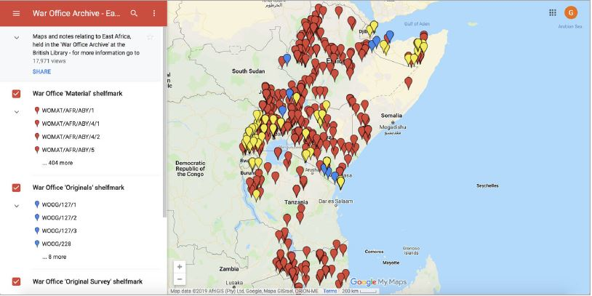
Figure 1. Screenshot of the War Office Archive East Africa map, created using Google My Maps.

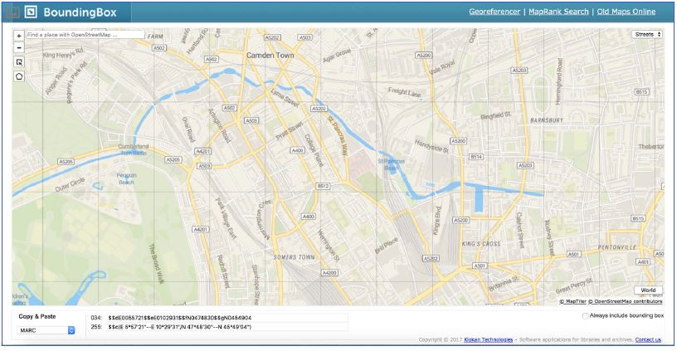
Figure 2. Screenshot of the Bounding Box tool.

Another separate DSTP training day dedicated to the tool OpenRefine was also relevant to research and access needs. OpenRefine is an open source platform for data cleanup and transformation. The DSTP has been running OpenRefine training days several times a year, delivered by external consultant Owen Stephens. Stephens regularly teaches British Library staff the basic capabilities of this tool to clean and normalize data (O. Stephens, “Working with data using OpenRefine,” November 19, 2014, http://www.meanboyfriend.com/overdue_ideas/2014/11/working-with-data-using-openrefine/). To create a more tailored training day to fit with the Season of Place, on this occasion he covered a couple of location-related topics: retrieving data from online sources (using Named Entity Recognition) and using “reconciliation” services to match local data to external data sources.
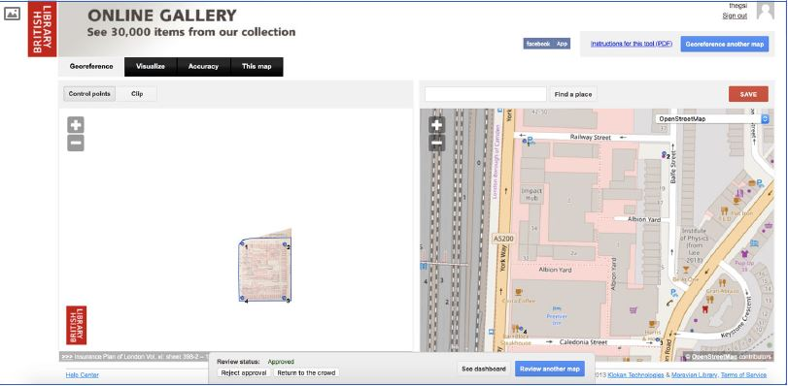
Figure 3. Screenshot of the Georeferencer platform.

Inspiration. As part of the training we also wanted to demonstrate British Library projects that have successfully made use of digital mapping both to raise awareness and to spark ideas amongst participants. The Georeferencer tool has been used to crowdsource the georeferencing of over 45,000 digitized maps from the Library collection since 2011 (Figure 3). Developed by Klokan Technologies and now widely used by map libraries, the tool allows volunteers to locate images of print maps in a geo-graphic space by connecting geographical features shown in the image to the same features depicted on a web map. Once sufficient points have been added, the tool warps the image to be displayed on top of the print map. The Library can then access the resulting geospatial data and import it into catalog records as a bounding box, or use it to create GeoTIFFs for research use. The Georeferencer has been a great success story, with thou-sands of volunteers contributing geospatial data for these historic maps (Kowal and Pridal 2012). Teaching the Georeferencer provided staff with several benefits. First, the tool provides users with a clear understanding of the difference between an image and raster data, offering a practical method of improving geospatial literacy. Second, its use will develop an understanding of crowdsourcing and its value and utility within libraries. Third, we hoped to inspire and motivate by demonstrating just how much enthusiasm there is amongst the public for working with our collections.
Workshops and Hack & Yacks
In addition to the full-day training courses, the Digital Curator team has been upskilling Library staff through monthly informal sessions christened “Hack & Yacks”. These hands-on sessions allow staff to learn about an individual tool over the course of two hours by working through online tutorials collaboratively. Similar to DSTP training days, they take place in a bespoke training room, which sets the tone for a collaborative mindset, where people could try to experiment and explore digital tools together. For the Season of Place, tools were chosen for a Hack & Yack according to many of the same criteria as training days, in that they had to be accessible and fit within the overall aims of the season. Additionally, they had to have a high-quality tutorial available online. Hack & Yacks were useful to broaden the scope of the season and to foster discussion on potential applications for digital mapping in the Library. We gained a lot of informal feedback through these events and it should be noted that the preparation workload is considerably smaller than a formal training day requires.
We ran two Hack & Yack sessions and coordinated one workshop. The first Hack & Yack was dedicated to ESRI Story Maps—a user-friendly, free and open-source tool to create captivating stories with media and maps. We used an online Story Map Tour Tutorial for this purpose. In the second Hack & Yack session we looked at Tableau Public—a free service for creating interactive data visualizations online. Visualizations could be embedded into web pages and blogs, shared via social media or email, and made available for download. We appropriately focused on creating map visualizations, using a tutorial created by Kristen Mapes from the College of Arts and Letters at Michigan State University. Similar to DSTP course materials, Hack & Yack tutorials could be referred to through the Library’s internal wiki.
In addition to these regular sessions, we occasionally organize workshops delivered by external experts. A more structured workshop session with guided exercises was delivered by Dr Valeria Vitale, to showcase Recogito. This workshop expanded on the exercise created for the DSTP training days, which focused on geoparsing. Vitale demonstrated some of Recogito’s capabilities and functionalities, such as creating annotations, identifying place names in uploaded documents (text, images, tabular data), and exporting data. This platform is maintained by Pelagios Commons, and the workshop was preceded on the day by a staff talk delivered by Prof Leif Isaksen (see next section).
21st Century Curatorship Talks and Digital Conversations
The Digital Scholarship team hosts a series of professional development talks and seminars entitled “21st Century Curatorship Programme”. Open to all Library staff, these talks provide a forum for keeping up with new developments and emerging technologies in scholarship, libraries and cultural heritage. We were honored to host several external speakers who shared their ideas and projects with staff. Speakers and topics included Sally Bushell and Rebecca Hutcheon (Lancaster University) talking about “Chronotopic Cartographies and Litcraft: Mapping Space and Time in Literature”; John Hessler (Library of Congress) presenting on “Machine and Deep Learning for Librarians: Designing Tools for Collections Discovery in the 21st Century”; Leif Isaksen (University of Exeter) on “How to Decide What to Where: Semantic Geo-annotation and the Pelagios Network” (linking up other teaching modules, the Recogito exercise and Vitale’s Recogito workshop, mentioned above); and Sam Griffiths (UCL Bartlett School of Architecture) talking about “Exploring the interface of political meeting places and urban space in Ancoats, Manchester c.1780–1860.” These talks broadened the season and helped participants to understand how the methods they were learning about could be applied to real research issues.
The 21st Century talks were complemented by a “Digital Conversation” talk, a quarterly series where inspirational and creative individuals are invited to share short, thought-provoking presentations on a theme associated with digital transformations in research. These conversations are open to the public and offer an invaluable opportunity for lively discourse and debate between audience and panel. Our panel on “Data, Place and Digital Economies”, chaired by the Library’s Head of Contemporary British Publications Ian Cooke included Mark Birkin, Miranda Marcus, Jeremy Morley and Emmanouil Tranos (S. Wisdom, “Digital Conversations @BL: Data, Place and Digital Economies,” January 11, 2019, https://blogs.bl.uk/digital-scholarship/2019/01/digital-conversations-data-place-and-digital-economies.html). The speakers explored the spatial information included in web archives and other collections, demonstrated innovative uses of these rich datasets, and discussed the ethical and technical challenges that accompany their use. These two types of talks offered an additional channel of engagement, broadening the scope of the Season of Place and providing inspiring examples of digital mapping in action.
Evaluation
We employed several methods to evaluate the effectiveness and impact of the season, focusing especially on the two DSTP training days. The first involved our own perceptions of teaching and events and informal observation of and conversations with participants. Second, we were interested in comparing our teaching with that across the Digital Scholarship program as a whole. Third, and most importantly, we sought formal feedback through surveys. We designed and used a series of feedback forms that were sent out to participants at intervals after completion of the training days. We were particularly interested in perceptions of the tools we taught and whether they went on to be used, if they were relevant to participant’s roles and if participants were sufficiently motivated to apply them to the Library’s collections. Evaluation forms for the two digital mapping training days were circulated and completed by participants immediately after the training (on the day, or within several days), and after three months. A third survey is planned to be sent a year after the training days, taking place in early 2020. Through collecting feedback over this long timescale, we hoped to pick up whether particular tools were used and the extent to which staff had managed to embed them in their roles. The next section will outline the results of the two initial surveys.
Initial Evaluation Survey
Out of 29 course participants, twenty-one filled in our evaluation forms circulated immediately after the training took place. Participants were asked what it was that they had most enjoyed during the training days. Most mentioned the hands-on sessions and practical experience, “being able to put concepts into practice immediately.” Attendees enjoyed the interactive nature of the training—engaging with different platforms, getting the chance to use and explore tools and software, and learning about available functionalities—as well as the range and diversity of examples, projects, mapping tools and case studies covered in the training. The most popular tools and platforms that were specifically mentioned were Google My Maps and Recogito.
Participants were then asked whether there was anything in particular that they anticipated they would use in their work. Google My Maps, Recogito and Palladio were specifically mentioned, and more broadly, useful learning areas included geoparsing to extract place names from collection metadata, the creation of maps for publications, map visualizations, understanding the geographic metadata in the Library’s cataloging systems and particularly the creation of spatial data related to sound. Although participants commonly indicated that they were not yet sure what they were going to use, they did feel that familiarity with a range of platforms, projects and tools, might help with future projects.
Lastly, participants were asked whether anything was not clearly articulated, whether some topics could have been covered in more depth, and whether they had any suggestions to help improve the training days in the future. We received several helpful comments and suggestions, especially focusing on methods of training delivery. A couple of participants felt they needed more time to get used to the different systems in two of the practical sessions, while another would have liked further conversations with the instructors during the practical sessions, talking through particular ways of using tools or raising specific questions. Two others suggested that the instructors demonstrate first how to use tools before they dove into the exercises individually. Another comment referred to one of the introductory talks, indicating that items were pitched at a level that was too high for them, and that a lower-level explanation of metadata was required.
Further important suggestions were made, such as the need to under-stand how the methods taught could be implemented at scale and within the Library’s cataloging systems. One participant would have liked to learn more about how to prepare data as they were unsure how to manipulate their own project data into a format that could be used in the tools that were taught. Further guidance was needed if learning was to be implemented in real-life projects and datasets. Future training might help participants to work a single set of data through various stages, providing opportunities for concrete issues and queries to be raised perhaps through a “mapping” clinic. Another suggestion was to have a more elaborate discussion on the analytical potential of geographic data, to provide an under-standing of the types of research questions that could be answered with the help of spatial data.
Three-Month Evaluation Survey
Out of 29 course participants, thirteen filled in our evaluation forms circulated three months after the training took place. Participants were asked what they were hoping to get out of the training sessions. Responses indicated that understanding the options available for mapping and visualizing data was a priority and that participants hoped to find inspiration in how digital mapping might be implemented in their areas of work. Other participants were interested in broadening their knowledge around digital librarianship and digital reference skills. When asked to self-define their level of knowledge and skills prior to attending our training days, on a scale of “0” to”10”, participants’ responses were spread across the first half of the scale, mostly at level “4” or “5”. After attending our mapping training days, the level range moved up the scale, from “4” to “7”, with most participants ranking themselves at “7”. Asking participants to rate their level of confi-dence in applying the learning within their work, 46.2% felt some confi-dence and 38.5% were “fairly confident”, however 15.4% felt no confidence. None of the respondents chose the options “confident” or “very confident” (Figure 4).
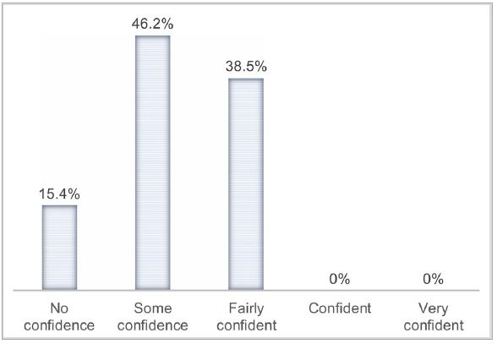
Figure 4. Chart showing participants’ level of confidence in applying their learning within their work.
Most participants (61.5%) indicated that the training days were “fairly relevant” to their work, while 38.5% indicated they were neither relevant nor irrelevant (Figure 5). Assessing how often attendees use the knowledge or skills gained from the training days, 53.8% were annual users, 15.4% monthly users, and 30.8% of participants never use these type of skills in their work (Figure 6). Most participants felt that they could find support from the Library in order to implement their training (76.9%), and some indicated this was not applicable to them (23.1%). None felt that they were unsupported in the area of digital mapping.
When asked about areas of learning that training-day attendees use in their work, most indicated that they were yet to put their learning into practice, but felt that gains in knowledge and awareness were already useful to them. Two participants were looking into using Google My Maps, Palladio and Recogito within the following few months. Being asked more specifically about tools being used following the training, four used Google My Maps, two used Recogito, one used the Bounding Box tool, and one used Palladio (Figure 7).
We were then interested to know if attendees had created, visualized or analyzed any geospatial data, or whether they had done anything in par-ticular using knowledge from the training within three months. Most participants had not yet had the chance to put their learning into practice within that time frame, but were positive about knowing where to start in the future. One participant mentioned that the training day drove them to do further research on visualizing spatial data for their project, and another indicated the training day had helped them think about creating visualizations using Power BI. Another participant was inspired by the geoparsing module and Recogito, and used OpenRefine and Dandelion API to extract place names from unstructured text.

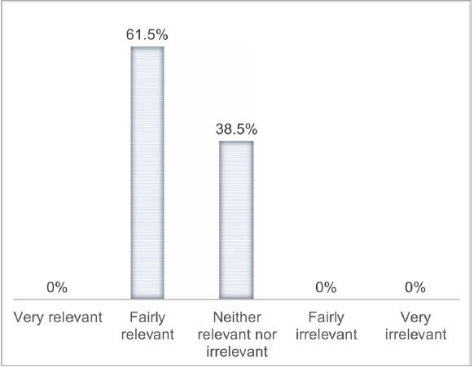Figure 5. Chart showing ratio of relevance of the training days to participants’ work.

Lastly, participants were asked what the Digital Scholarship team could do to further support them in the area of digital mapping. Several mentioned that further training and support clinics and consultancy could be useful. Two specifically referred to the Recogito two-hour workshop, which took place soon after both training days, as an effective method of complementing training. One participant wrote:
I found this course useful at introducing technologies, but the course wasn’t long enough to come away feeling confident in using these technologies. Not long after this course there was a Hack and Yack on Recogito. This provided a perfect complement to the intro session, a great way to get to know the software. So, follow-up events like this, which enable a more detailed focus on one piece of software led by a professional trainer in that software, would be a great way to build on this introduction.
Discussion
In light of the feedback we have received, comparisons to previous DSTP training, and our own perceptions of training events, we feel that the Season of Place was broadly successful in meeting our aims of improving geospatial literacy, offering participants methods of improving access and research, overcoming many of the challenges discussed earlier. The season has developed our knowledge in three areas that potentially have wider implications: teaching methods, season design and our choice of digital tools. This section will look into lessons learned, evidence of impact, and remaining challenges to overcome when planning for future training.

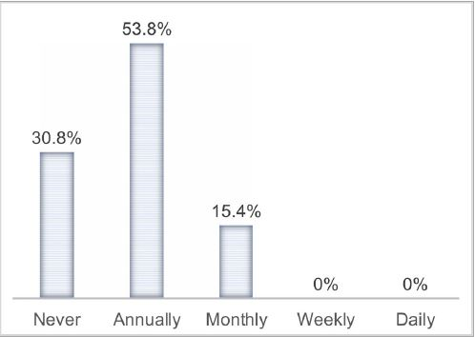
Figure 6. Chart showing the frequency of applying knowledge or skills gained from the training days.
Teaching Methods
Our methods of delivery worked well in several important respects. Teaching some tools in a more informal, peer-led manner and others in a more traditional classroom style alongside talks was an effective mix. The rationale behind running Hack & Yack and other practical sessions stemmed from a broader DH trend to complement theoretical teaching with practical training (see e.g. Pannapacker 2013; Magis 2018). Class layout and group size proved to be beneficial for practical, hands-on training. A group size of no more than 15 participants (reduced from 30 participants previously), as well as a communal room layout, enables and encourages an active and vibrant learning environment and one-to-one interaction with instructors. The latter enabled us to troubleshoot more effectively, receive feedback directly, and engage with conversations on potential uses of data and digital platforms.
Hands-on practical exercises were often mentioned as the most enjoyable element in our digital mapping training days, provided they were balanced with theoretical and introductory sessions. This conforms to feedback received on other DSTP courses (McGregor et al. 2016). Exploration of tools by participants is beneficial and worthwhile provided sufficient time for hands-on practice is allocated. We plan to keep using the hands-on method for teaching new tools and platforms, making sure practical sessions are long enough and provide ample opportunities for participants to explore and discuss. From our experience, a 30-minute session is too short, and ideally hands-on sessions should take 45 minutes or longer. The survey feedback does suggest that the optimal length of time for practical exercises varies between participants. Whilst some found the allocated time to be sufficient, others felt certain tools demanded more time than was allocated. Similarly, some participants felt that aspects of their training were pitched at too high a level, one interesting example being assumed prior knowledge of Library systems. These issues exemplify our challenge to deliver training to a very diverse audience, holding different roles and with different levels of expertise and experience.
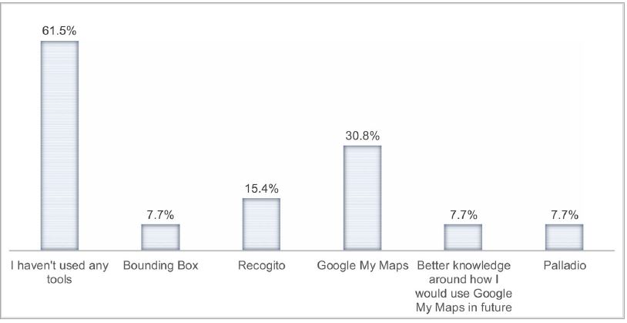
Figure 7. Chart showing the uptake of tools following training days.
A related challenge is the gap that attendees felt existed between the con-tent of training days and applications to real-life data. Teaching the tools as stand-alone software and providing pre-prepared datasets was essential given the time available and background of participants. However, feedback demonstrates that this approach did not provide all participants with the confidence, skills or understanding to go away and immediately use the tools in their own collection areas. In order to join-up collections with the tools, a workflow is needed that requires working with data extraction, cleaning, processing and wrangling using tools like text editors, spreadsheet software and command line utilities. Improvement in data literacy might be achieved by adding a practical or clinic session, less top-down in orientation, where participants bring their own data, questions and ideas. This could be held as part of the training day, which would mean teaching fewer tools, or as a separate session after the training, perhaps focused on a specific tool and in response to feedback (see more below).
Season Design
The season format offered significant benefits and it became clear that the use of diverse types of training events reinforce learning and improve digital literacy overall. By providing opportunities for modularity, for example combining interconnected events such as a talk, a hands-on exercise and a specialized workshop as we did with Recogito, participants gained a deeper, more contextual understanding and were more likely to be inspired to implement the teaching. However, the feedback recorded after three months demonstrates that no participant came out of the training days feeling “confident” or “very confident”, a significant finding. It goes hand in hand with comments about the need for further training, focusing on specific tools or on specific types of datasets.
The need for more advanced and/or better tailored training is in line with wider DSTP challenges. McGregor has already noted that “in an ideal world we could offer ‘just in time’ training to colleagues at the point of their immediate need” (McGregor et al. 2016). However, it may not always be possible to respond well to colleagues’ specific needs due to time and resource constraints. We will keep looking into user requirements on a case by case basis, and attempt to respond to staff needs accordingly. Where appropriate, we could create teaching modules complementary to training, to bridge knowledge gaps, increase confidence and eventually empower staff to put their digital mapping skills into practice.
More often than not our training events were highly attended, showing that staff members were able to take part and were not put off by the number of different events. Indeed, the popularity of the 21st Century Curatorship talks delivered by external speakers and positivity in evaluation forms demonstrate that people enjoy different ways of learning, from being on the receiving end of a presentation to actively participating in hands-on, collaborative workshops. This was heartening as without generating enthusiasm and inspiration we cannot expect staff uptake. It should be noted that organizing this multitude of events was a significant undertaking, and finding capacity was challenging, a factor that should not be underestimated when planning a similar format. We also benefited from the Library’s location in London, which made it relatively easy to invite visiting speakers and instructors to participate, many of whom were passing through the city. This advantage helped us to create a very diverse season plan, featuring external experts and specialists that greatly enriched the learning experience of Library staff.
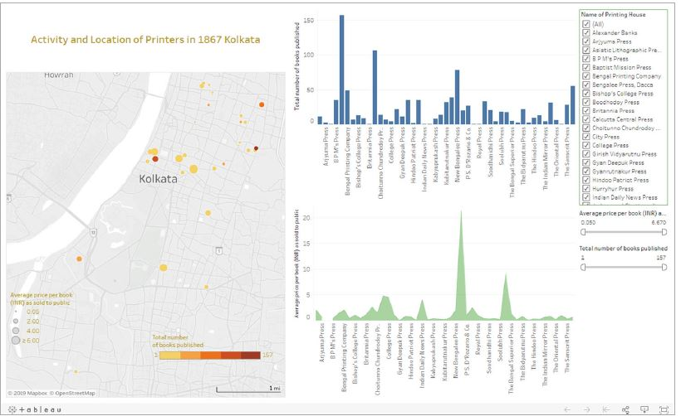
Figure 8. Map of activity and location of printers in 1867 Kolkata, created using Tableau Public.
Digital Mapping Tools
Looking specifically at the DSTP objectives, there is some evidence to demonstrate the value of our selection of tools. The feedback suggests that participants both enjoyed learning about our chosen tools, and also found them useful and relevant to their work. This vital information demonstrates the importance of tool choice for delivering a positive learning experience. Many participants commented that just the introduction to different tools, platforms, and digital mapping case studies was a valuable exercise in itself, helping them understand digital mapping options and functionalities and increasing digital literacy. Attendees cited specific technologies as some-thing they anticipated using in their work, with several experimenting with tools such as Google My Maps and Recogito. The selected tools were relevant to staff needs, particularly for access and research. As indicated by evaluation surveys, many participants attended training days with the general intention of improving literacy and confidence, rather than to specifically create digital maps. Designing forms that measure improvement in these areas is difficult as their intangible character is difficult to quantify.
Yet our season intended to go further, achieving impact by inspiring participants to use digital tools in their research and to improve access. Since the Season of Place ended, we have heard about several use cases. Following the Hack & Yack session on Tableau Public, Tom Derrick, Digital Curator for the Two Centuries of Indian Print project, created a map visualizing the activities and location of printers in 1867 Kolkata using this tool (Figure 8). Tom used teaching resources on our internal wiki, demonstrating the importance of making materials available for those who could attend training events, or who would like to consult them at a later stage. Another use case following a different Hack & Yack session came from a member of the British Library/Qatar Foundation Partnership team. She created an ESRI Story Map entitled “Sounds of the Past, Discovering the female voices of the Arab World,” for International Women’s Day 2019.
Our survey feedback from the DSTP training days has not yet provided concrete examples of how course participants used digital mapping tools to map the Library’s collections, whether that be embedding maps on the British Library website to improve access to collections, or research analysis based on geospatial methods that were taught. Getting clear insights from our three-month evaluation forms on tool usage was probably too ambitious, as new technologies do take time to be embedded in work practice. We shall look forward to learn more about practical use cases through our one-year evaluation survey, and via informal conversations with colleagues. Only then can we determine whether the tools we selected matched the Library’s needs.
Conclusion
We have found the diversity of events that the Season of Place has offered to be useful and rewarding pedagogically, providing fora for participants to develop both theoretical and practical understandings of digital mapping. The season had the potential to make a significant contribution toward the British Library’s core aims of facilitating research, access and inspiration. The events that we ran and the tools that we chose were organized to empower staff to contribute toward those aims. Whilst we can point to a handful of applications that evidence this achievement, over the longer term we hope that benefits to digital literacy and knowledge of web maps will continue to inspire staff. The season, and the feedback that we received, have highlighted both the achievements that the DSTP as a whole has made, and the potential for future development through its training design and delivery. The Season of Place training days, and DSTP courses and training sessions more broadly, have reflected the significant challenges that the Library confronts when training its staff. We are expected to teach complex topics, cater for a varied audience with different needs and diverse technical abilities, and work within challenging time and resource constraints. We will however keep striving to fulfill our aims, improving our teaching of digital mapping approaches and practical tools alongside emerging areas of scholarship and uses of our digital collections more broadly.

Acknowledgements
The authors would like to thank Magdalena Peszko for her contribution to training and for her comments on a draft of the paper. Thanks also to the Digital Scholarship team for their feedback and their contributions to the success of training at the British Library as a whole. Finally, thanks to all the British Library staff who participated in the “Season of Place” training events and who took the time to fill in their evaluation forms. Without their feedback, this paper wouldn’t be possible.

Digital Scholarship Staff Training Programme website. Accessed July 3, 2019. https://www.bl.uk/projects/digital-scholarship-training-programme.
Recogito website. Accessed July 3, 2019. https://recogito.pelagios.org/
Digital Humanities Awards website. Accessed July 3, 2019. http://dhawards.org/dhawards2018/results/.
The Pelagios Network website. Accessed July 3, 2019. https://pelagios.org/
Palladio website. Accessed July 3, 2019. https://hdlab.stanford.edu/palladio/.
Endangered Archives Programme website. Accessed July 19, 2019. https://eap.bl.uk/
Google My Maps website. Accessed July 3, 2019. https://www.google.com/maps/d/u/0/
War Office Archive - East Africa online map. Accessed July 3, 2019. https://www.google.com/maps/d/u/0/viewer?mid=1cAf4fqJK_-_zq8e2hCeAyy3C0e4&ll=-6.866810010279641%2C37.777849999999944&z=4
War Office Archive maps. Accessed July 3, 2019. https://www.bl.uk/collection-guides/war-office-archive
Bounding Box website. Accessed July 3, 2019. https://boundingbox.klokantech.com/
Qatar Digital Library website. Accessed July 3, 2019. https://www.qdl.qa/en
OpenRefine website. Accessed July 3, 2019. http://openrefine.org/
The British Library’s Georeferencer website. Accessed July 3, 2019. https://www.bl.uk/georeferencer/
ESRI Story Maps website. Accessed July 15, 2019. https://storymaps.arcgis.com/
Story Maps Tour Tutorial used in our Hack & Yack. Accessed July 15, 2019. http://storymaps-classic.arcgis.com/en/app-list/map-tour/tutorial/
Tableau Public website. Accessed July 15, 2019. https://public.tableau.com/en-us/s/
Tableau Public tutorial: Visualizing Data Using Tableau, 2016 Edition. Accessed July 15, 2019. http://www.kristenmapes.com/tableau/
Power BI website. Accessed August 5, 2019. https://powerbi.microsoft.com/
Dandelion API website. Accessed July 19, 2019. https://dandelion.eu/
Two Centuries of Indian Print website. Accessed July 21, 2019. https://www.bl.uk/projects/two-centuries-of-indian-print
Map of activity and location of printers in 1867 Kolkata. Accessed July 21, 2019. https://www.bl.uk/early-indian-printed-books/data-visualization
Sounds of the Past Story Map. Accessed July 21, 2019. https://www.arcgis.com/apps/Cascade/index.html?appid=d00cb9d0a62b4d459e55b52f9950c14b References Baggett, M., and R. Gibbs (2014) ‘Historypin and Pinterest for digital collections: Measuring the impact of image-based social tools on discovery and access. Journal of Library Administration, 54 (1):11–22. Bearman, N., N. Jones, N. I. Andre, H. A. Cachinho, and M. DeMers (2016), ‘The future role of GIS education in creating critical spatial thinkers’, Journal of Geography in Higher Education 40 (3):394–408. Bonacchi, C., A. Bevan, D. Pett, A. Keinan-Schoonbaert, R. Sparks, J. Wexler, and N. Wilkin (2014), ‘Crowd-sourced archaeological research: the MicroPasts project’, Archaeology International, 17:61–8. Coleman, N., D. Edelstein, and P. Findlen (2017), Networks in History: Data-driven tools for analyzing relationships across time. White Paper. Report ID: 110202, Stanford University. Accessed July 19, 2019. http://dx.doi.org/10.17613/M6WM0D. Huisman, O., and R. A. de By (Eds.) (2009), Principles of geographic information systems: An introductory textbook. 4th ed. Enschede: International Institute for Geo-Information Science and Earth Observation. Kowal, K. C., and P. Pridal (2012), ‘Online georeferencing for libraries: The British Library implementation of Georeferencer for spatial metadata enhancement and public engagement’, Journal of Map & Geography Libraries 8:276–89. Magis, C. (2018), ‘Manual labour, intellectual labour and digital (academic) labour: the practice/theory debate in the Digital Humanities’, Triplec: Communication, Capitalism & Critique. Open Access Journal for a Global Sustainable Information Society 16 (1):159–75. McGregor, N., and A. Farquhar (2013), ‘The Digital Scholarship Training Programme at British Library’ Abstracts | Digital Humanities 2013. Accessed July 19, 2019. http://dh2013.unl.edu/abstracts/ab-264.html McGregor, N., M. Ridge, S. Wisdom, and A. Alencar-Brayner (2016), ‘The Digital Scholarship Training Programme at British Library: Concluding report & future develop-ments’. In Digital Humanities 2016: Conference Abstracts, 623–25. Krak􀀁ow: Jagiellonian University & Pedagogical University. Accessed June 5, 2019. http://dh2016.adho.org/abstracts/178 Pannapacker, W. (2013) ‘“Hacking” and “Yacking” about the digital humanities’, The Chronicle of Higher Education 60 (1). Accessed 19 July 2019. https://www.chronicle.com/article/HackingYacking-About/141311 Roset, R.,. V. Pascual, and C. Montaner (2015), ‘From gazetteer to Bounding Box: Using SDI standards to build a geoportal for ancient maps in Catalonia’, e-Perimetron 10 (1):11–25. Simon, R., E. Barker, L. Isaksen, and P. D. S. CaNamares. (2017) ‘Linked Data annotation without the pointy brackets: Introducing Recogito 2’, Journal of Map & Geography Libraries 13:111–32. Won, M., P. Murrieta-Flores, and B. Martins (2018), ‘Ensemble Named Entity Recognition (NER): Evaluating NER tools in the identification of place names in historical corpora’, Frontiers in Digital Humanities 5:2. Appendix 1. Summary list of digital tools mentioned in the paper Tool Description Link Bounding Box A free tool created by Klokan Technologies, allowing to extract geospatial data in various formats by stretching a rectilinear polygon over a web map. https://boundingbox.klokantech.com/ Dandelion API A service created by SpazioDati for extracting, classifying and analyzing entities from unstructured text. https://dandelion.eu/ ESRI Story Maps An ESRI tool that combines maps with narrative text, images, and multimedia content to create compelling stories. https://storymaps.arcgis.com/ Georeferencer A tool developed by Klokan Technologies, used by the British Library to crowdsource location data and georeference scanned historic maps. https://www.bl.uk/georeferencer/ Google My Maps A free tool that allows the creation and editing of custom web maps, based on Google map tiles. https://www.google.com/maps/d/u/0/ Historypin A web map platform that enables people to share photos and stories, telling the histories of their local communities. https://www.historypin.org/en/ Layers of London A map-based history website allowing users to access free historic maps of London and contribute stories, memories and histories. https://www.layersoflondon.org/ MicroPasts A PyBossa-based crowdsourcing platform which supports massive online data collection about the human past (archaeology, history and heritage). https://crowdsourced.micropasts.org/ OpenRefine A free and open source tool for working with messy data: cleaning, transforming, and extending it with web services and external data. http://openrefine.org/ Palladio A suite of visualization and analytical tools that can be used to visualize data in several ways including maps, timelines and networks. https://hdlab.stanford.edu/palladio/ Power BI A business analytics service by Microsoft for visualizing, analyzing and sharing data. https://powerbi.microsoft.com/ Recogito An online platform for collaborative document annotation (text, image or tabular data), initiated by the Pelagios Network. https://recogito.pelagios.org/ Tableau Public A free Tableau service for creating and publishing interactive data visualizations online. https://public.tableau.com/en-us/s/

