Karl and Eleanor Marx – Life in the Reading Room, 1 May – 5 August 2018, British Library Sir John Ritblat Treasures Gallery

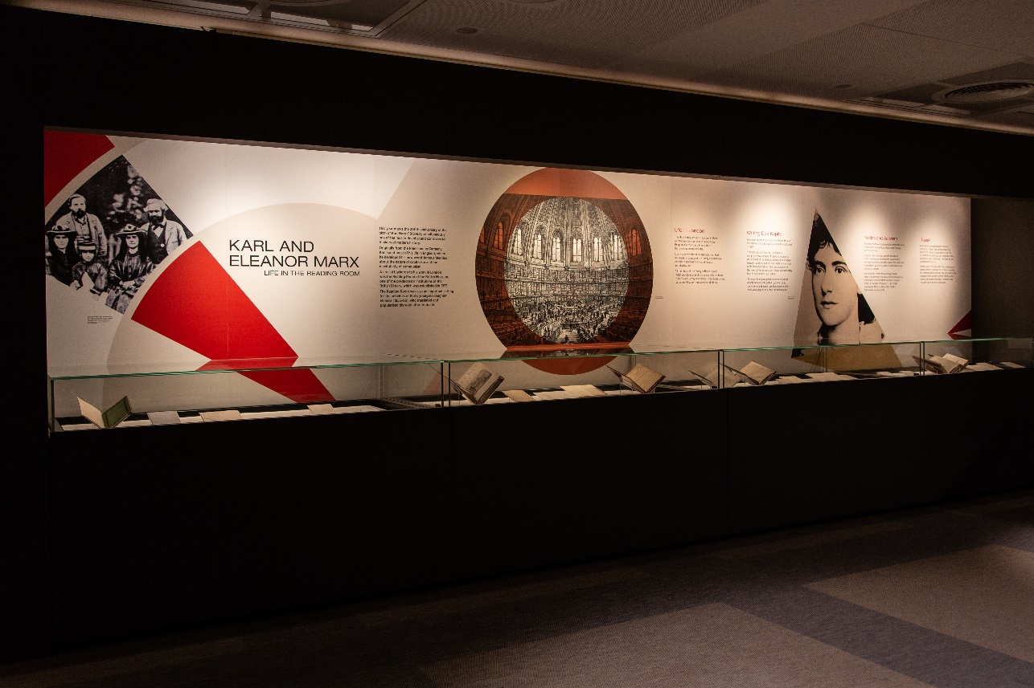
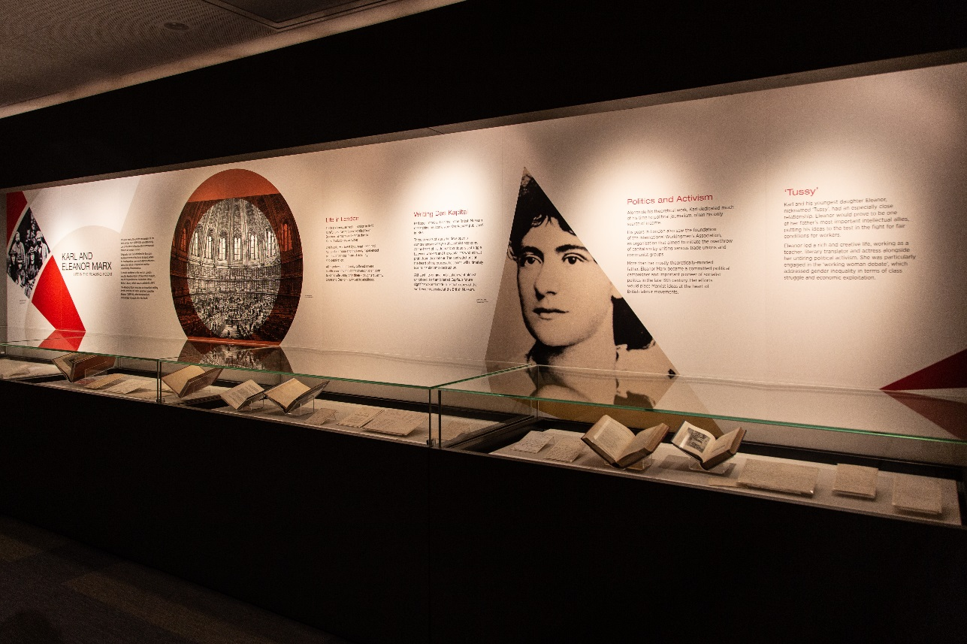
Image captions:
Friedrich Engels, Karl Marx and the three Marx daughters Laura, Eleanor (middle) and Jenny, London 1864. © Private Collection / Roger-Viollet, Paris / Bridgeman Image
The Reading Room of the British Museum.
Eleanor Marx, 1898. © Universal History Archive/UIG/ Bridgeman Images
Exhibition board text by Diana Siclovan with Izzy Gibbin (2018)
Board texts
Karl and Eleanor Marx – Life in the Reading Room
This year marks the 200th anniversary of the birth of Karl Marx (1818–83), simultaneously one of the most influential and controversial thinkers of modern history.
Originally from the Rhineland in Germany, Karl spent most of his life in England, where he developed his now world-famous theories about the nature of capitalism and the inevitability of communism.
A crucial backdrop to his work in London was the Reading Room of the British Museum, one of the predecessor institutions of the British Library, which was established in 1973.
The Reading Room was also an important setting for the activities of Karl’s youngest daughter Eleanor (1855–98), who translated and popularised his work after his death.

Life in London
The Marx family arrived in London in 1849 as refugees, having been expelled from Belgium, Germany and France due to Karl’s revolutionary activities.
Life in exile was beset by struggle. Karl had no regular income and the family experienced periods of perilous financial difficulty and deprivation.
All members of the family suffered severe health problems and of the seven children born to Karl’s wife Jenny only three – daughters Jenny, Laura and Eleanor – survived to adulthood.

Writing Das Kapital
Karl spent most of his time in the British Museum researching his iconic work Das Kapital, published in 1867.
Through years of study he developed a comprehensive analysis of capitalist economy. At the heart of his dramatic critique is a struggle between workers and the capitalists who extract profit from their labour. The contradictions at the heart of this process, he claims, will ultimately lead to capitalism’s destruction.
Although its original publication went almost unnoticed, Karl anticipated Capital’s future significance and made sure that copies of the work were deposited at the British Museum.

Politics and Activism
Alongside his theoretical work, Karl dedicated much of his time to political journalism, often his only source of income.
His years in London also saw the foundation of the International Workingmen’s Association, an organisation that aimed to initiate the overthrow of capitalism by uniting various trade unions and communist groups.
More than her mostly theoretically-minded father, Eleanor Marx became a committed political campaigner and important pioneer of socialist politics in the late 19th century. Her efforts would place Marxist ideas at the heart of British labour movements.
‘Tussy’
Karl and his youngest daughter Eleanor, nicknamed ‘Tussy’, had an especially close relationship. Eleanor would prove to be one of her father’s most important intellectual allies, putting his ideas to the test in the fight for fair conditions for workers.
Eleanor led a rich and creative life, working as a teacher, literary translator and actress alongside her untiring political activism. She was particularly engaged in the ‘working woman debate’, which addressed gender inequality in terms of class struggle and economic exploitation.

